1. **Project Proposal (Due 6/11/2025)**

**Title**: Retail Clothing Stock Manager

**Team Members**: Alex Secor (Sas24e) and Jose Solano (Jls23k)

**Description**: A backend system for retail stores to track stock by size, brand, and type. This is done with a CRUD interface, which means Create, Read, Update, and Delete. For security reasons, users are prompted for a login username and password to modify any stock information.

**Problem statement**: Some clothing stores still manually register their inventory count on paper; this creates a bigger risk of human error in the form of miscounting and bad management when finding what items need replenishing because of their low stock. A retail clothing stock management program will enhance work efficiency by keeping track of the clothing inventory stock and notifying workers of what items are low on stock, making the job of retail workers easier while diminishing the chances of human error, which can sometimes cost the retail store money.

**Proposed Features:**

● CRUD Interface

○ Estimated Work Hours (20hr)

● Login / password for web page usage.

○ Estimated Work Hours (10hr)

● Inventory management (Stock alerts)

○ Estimated Work Hours (10hr)

● Create / Read/ Update /Delete (CRUD) inventory.

○ Estimated Work Hours (20hr)

● Data: products, sales logs, admin entries, and sales records.

○ Estimated Work Hours (20hr)

**Tech stack:**

● Frontend: HTML, CSS and JavaScript

○ We chose HTML as the assignment requires a web page.

○ CSS will play a large role in styling the website

○ JavaScript will help expand the functionality of the website.

● Backend: PHP

○ PHP is well-supported by our hosting provider (000webhost) and allows for rapid development of server-side logic.

● Database: MySQL

○ Provides structured storage and efficient querying for clothing inventory, users, and sales logs.

● Hosting: 000webhost

○ Free web hosting services allows us to host our database and supports web programs that utilize PHP files.

**Target users and benefits**: The target users are business owners and retail workers who want to track the stock and sales and modify the clothing information stored inside the database through the interface. Simplifies job tasks for retail audits for employees and alerts for clothes on low stock. The overall benefit of the system is that it makes inventory management easier and more accurate, which helps forecast stock shortages and overages. A virtual stock management system allows a business to analyze sales and determine what’s working and what’s not in terms of hot items, etc.

**Benefits:**

● Data Analytics

● Stock Alerts

● Managing inventory levels

● Record keeping for future possible audits

● Required for an online website

● Helps reduce customer questions about stock

______________________________________________________________________________

1. **System Design Document (Due 6/13/2025)**

● **Use Case diagrams/ Description**

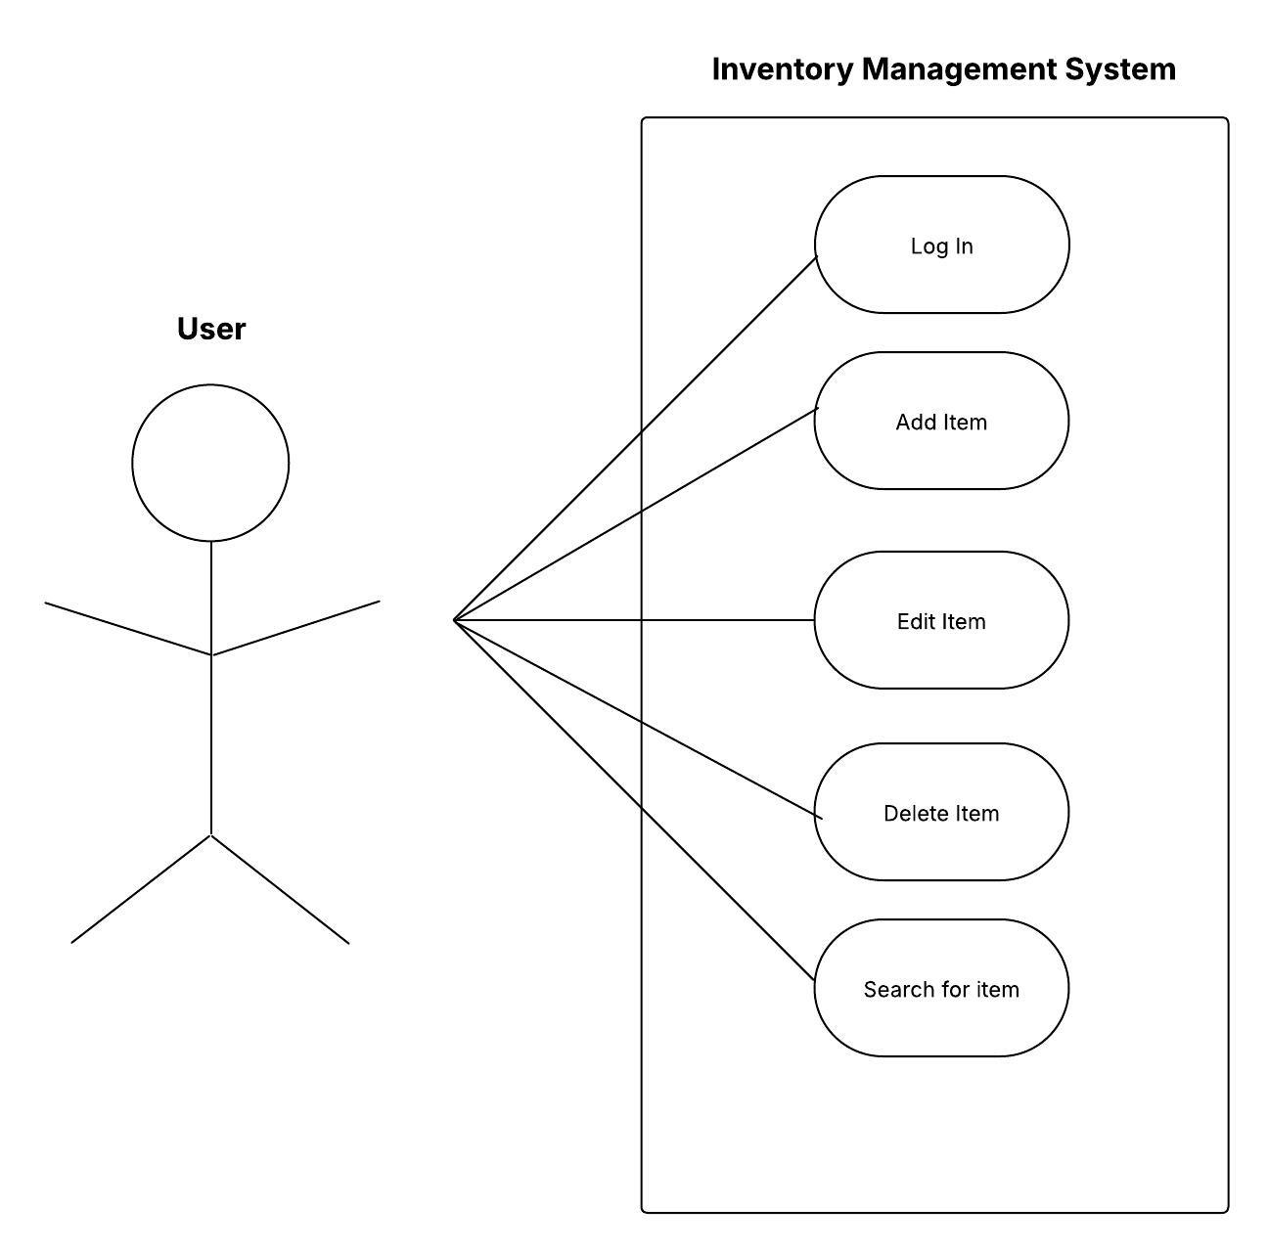

**Description**: When the user successfully logs in he will be able to add, edit, delete and search for clothing items all through the CRUD interface. Specific use cases will be to search for items low on stock and perform audits on the clothing inventory by searching through the entire list of items.

● **ER Diagram / description**

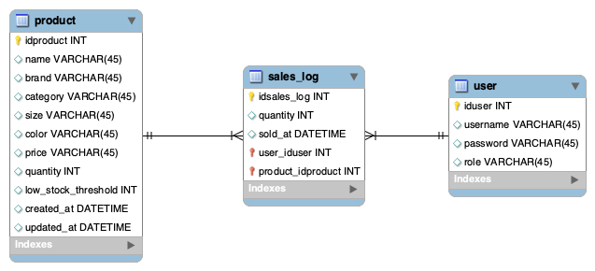

**Description**: Three sql tables all linked between each other for the management system to run as intended. The product table holds specific information about each type of clothing piece like the name, brand, category, price, quantity and a unique ID named idproduct which functions as the primary key.

The sales_log table keeps records of each item being sold, the quantity and the time that the item was sold, this is important as keeping track of sales shows how the quantity of stock on some items keeps diminishing therefore easier to track items that are low on stock. Sales_log table uses the idsales_log ID as a primary key to differentiate different sales being done. Also contains user_iduser and product_idproduct as foreign keys for better tracking between tables as the stock keeps updating.

The user table keeps track of the username, password and role of the user for improved security on who is able to access the management system. Sensible information like stock is crucial for businesses from an economic standpoint therefore the ability of editing and deleting stock should only be accessible to specific workers. The user table also includes a unique ID names iduser for each user registered inside the table with their included role.

● **Basic wireframes or UI mockups**

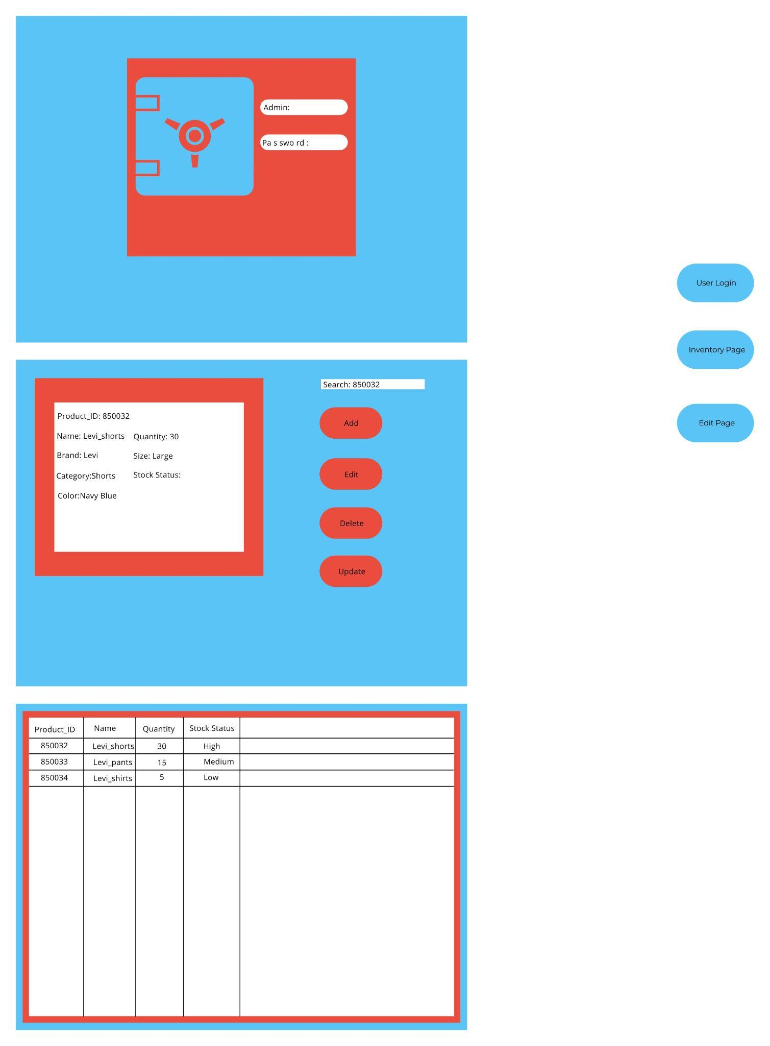

● **Architecture diagram (showing 3-tier structure)**

